Name: _____________________ Class:__________ Date:__________
Instructions: Write answers in the right-hand column. Score: ___________ / 55 marks
Section A— Multiple choice (10 marks)

 | Examine the diagram of the water cycle shown. Identify the processes occurring at 1, 2, 3, 4 and 5 in that order.  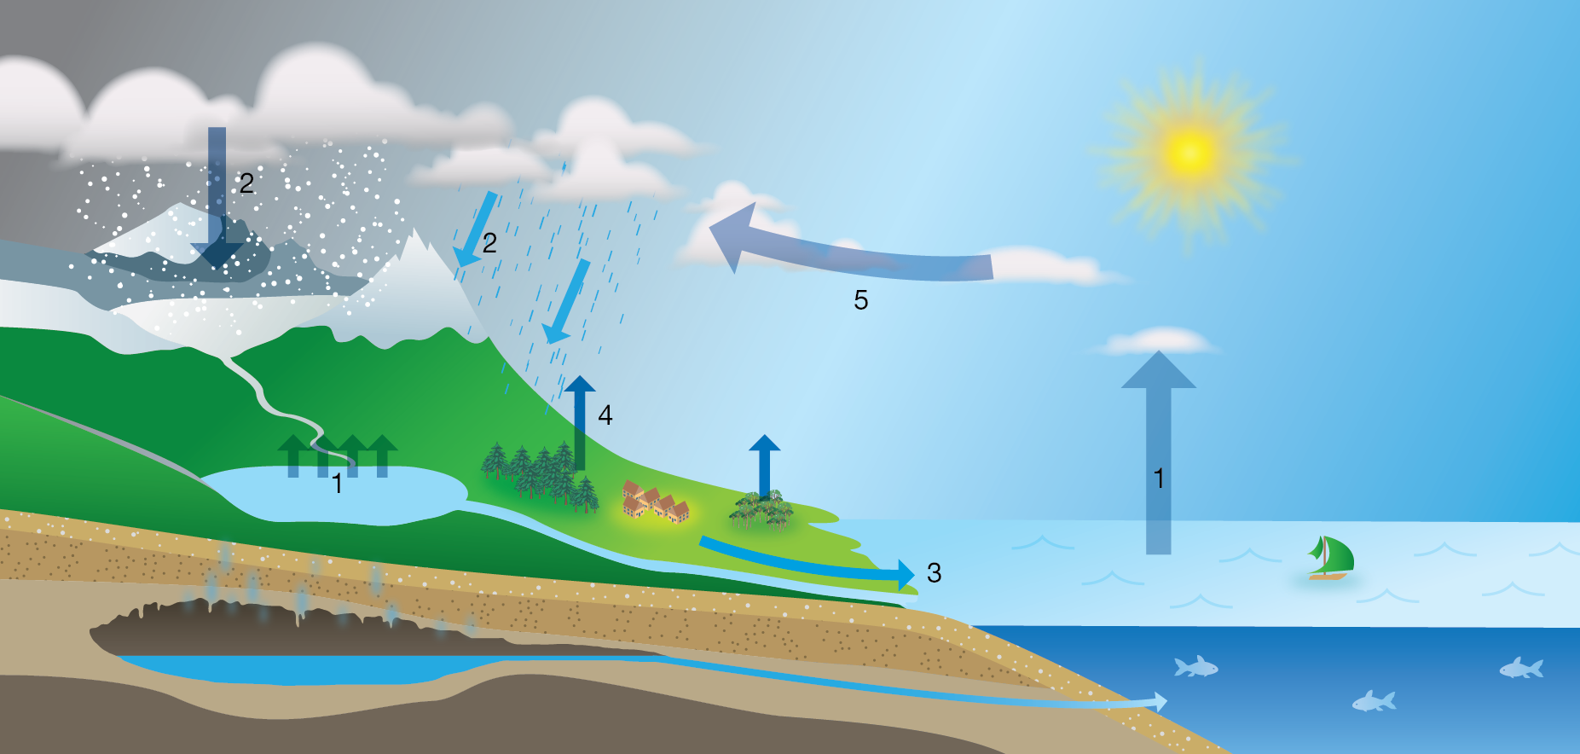  A evaporation; precipitation; run-off; condensation; transpiration  B precipitation; evaporation; transpiration; condensation; run-off  C evaporation; precipitation; run-off; transpiration; condensation  D transpiration; condensation; run-off; precipitation; evaporation | C | 1
 | Identify the best description of what global warming is.  A periods of global warming occur between periods of glaciation  B greenhouse gases in the atmosphere cause global warming  C global warming began after the Industrial Revolution  D during periods of global warming sea levels fall exposing more land | A | 1
 | Describe sustainable ecosystems.  A ecosystems that provide many different resources for humans  B stable ecosystems that have survived unchanged for thousands of years  C diverse ecosystems that provide for the needs of the organisms that live there  D ecosystems that survive without any input from humans | C | 1
 | Identify Earth’s largest and oldest long-term store of carbon.  A rainforest trees  B calcium carbonate  C fossil fuels  D carbon dioxide | B | 1
 | Compare the actions of nitrogen fixing bacteria and denitrifying bacteria in the nitrogen cycle.  A Nitrogen fixing bacteria absorb nitrogen from air. Denitrifying bacteria use nitrogen compounds in living things to obtain nitrogen.  B Nitrogen-fixing bacteria convert nitrogen into ammonia and then into nitrites. Denitrifying bacteria convert nitrites into nitrates.  C Nitrogen fixing bacteria absorb nitrogen from air and convert it into nitrates. Denitrifying bacteria convert nitrates into gaseous nitrogen.  D Nitrogen fixing bacteria release the nitrogen stored in the tissues of living things. Denitrifying bacteria absorb nitrogen from the air. | C | 1
 | Which statement does NOT describe greenhouse gases or the effect they have?  A Nitrogen and oxygen are greenhouse gases that absorb the short-wave radiation coming into Earth’s atmosphere from the Sun.  B Water vapour and carbon dioxide in the atmosphere have no effect on the short-wave radiation coming into Earth’s atmosphere from the Sun.  C Greenhouse gases trap heat close to the surface of the Earth keeping it warmer than it would be without those gases.  D Carbon dioxide and methane absorb long-wave radiation and re-emit it in all directions including back to Earth. | A | 1
 | Identify the list that contains some of the main causes of ocean currents.  A temperature; variations in salinity; revolution of the Earth around the Sun  B variations in salinity; rotation of the Earth; position of continents  C wind; position of continents; gravitational pull of the Sun and Moon  D gravitational pull of the Sun and Moon; temperature; rotation of the Earth | D | 1
 | Which statement does NOT describe the Southern Oscillation?  A During El Niño events the Southern Oscillation Index (SOI) is strongly negative. During La Niña the SOI is strongly positive.  B The Southern Oscillation has most effect on weather in central and southern Australia.  C The SOI is a measure of the atmospheric and ocean conditions across the Pacific Ocean.  D Where there is no El Niño or La Niña winds blow from the western Pacific Ocean to the east bringing average rainfall to Australia. | B | 1
 | Identify the statement that does NOT describe an effect of Antarctic ice.  A Ice acts as an insulator reducing the amount of heat that moves from the water into the atmosphere.  B As ice freezes salt remains in the ocean increasing the salinity and density of the water.  C Cold dense water at the Antarctic takes carbon dioxide from the atmosphere and into the deep ocean currents.  D Areas of ice reflect more of the Sun’s rays than forests. This has the effect of increasing Earth’s average temperatures. | D | 1
 | What is an UNLIKELY effect of global warming?  A Plants found on mountain tops will extend their range towards the lower slopes and valleys.  B Winters become shorter in many places so that the growing season is increased.  C Melting ice causes sea levels to rise inundating low lying areas.  D Animals found in warm seas will extend their range away from the equator and towards the poles. | A | 1
Section B— Short answer (35 marks)

 | Human activities have added extra carbon dioxide to the atmosphere, putting the carbon cycle out of balance. Propose some likely effects from a continued increase in levels of atmospheric carbon dioxide. | Adding CO₂ to the atmosphere is likely to cause increased average world temperatures. Possible flow-on effects include:  - rises in global sea levels  - changes in vegetation zones  - changes in ecosystem diversity and stability  - an increase in the incidence of diseases such as malaria, dengue fever and cholera  - more droughts, floods, cyclones and typhoons, with resultant crop failures leading to political and social upheaval | 3
 | Refer to Figure 1 at the end of this test.  The diagram represents part of the carbon cycle.  a Construct a statement for each of the numbered arrows, describing what happens at that step.  b Explain why the recycling of materials is important to the continued functioning of ecosystems. | a 1 Plant uses carbon dioxide (CO₂) in photosynthesis.  2 Plants become food for herbivores; carbon compounds present in plants become incorporated into animals’ tissues.  3 Cellular respiration produces CO₂ as a by-product, which is released back into the atmosphere.  b Recycling of materials ensures that substances become available again for use by plants and animals in the ecosystem. If materials were not recycled but were locked up in the dead remains of plants and animals, fewer and fewer resources would be available for new organisms. Eventually life would cease to exist. | 7
 | The emission of large amounts of carbon dioxide into the atmosphere by industry, coupled with the clearing of large areas of rainforest, has led to concern about an enhanced greenhouse effect.  a Explain how the clearing of rainforests contributes to the enhanced greenhouse effect.  b Potential problems associated with the enhanced greenhouse effect have been described. However, scientists suggest that some plant species may benefit. Explain how this may be so. | a There a many large trees and a variety of other plants in a rainforest. They all use carbon dioxide for photosynthesis and take it from the atmosphere. This reduces atmospheric carbon dioxide levels. Clearing of rainforests reduces the amount of carbon dioxide that is removed from the atmosphere therefore carbon dioxide levels remain high. Carbon dioxide is a greenhouse gas. Increased concentrations of carbon dioxide will retain more heat in the atmosphere leading to increased atmospheric temperatures.  b Plants need carbon dioxide for photosynthesis. An increase in atmospheric carbon dioxide may lead to an increase in photosynthetic activity in some plants. Such plant species may thrive in the new conditions. | 3
 | Refer to Figure 2 at the end of this test.  The diagram shows the nitrogen cycle.  Use your knowledge and the information presented in Figure 2 to complete the following.  a Explain why is nitrogen is an essential element for both animals and plants.  b Identify the form that nitrogen is in when dead plants and animals or their wastes begin to decay and nitrogen is returned to the environment.  c Describe the role of nitrifying bacteria.  d The air around us contains 78% nitrogen gas. Explain where plants get their nitrogen from. | a Nitrogen is an essential component of proteins.  b ammonia  c Nitrifying bacteria convert ammonia to nitrites and then to nitrates.  d Bacteria living in root nodules of leguminous plants are able to absorb nitrogen directly from the air and use it to produce nitrates. The nitrates they produce are available to the plants in which the bacteria live. Most plants cannot obtain nitrogen in this way and rely on nitrifying bacteria to convert ammonia in the soil to nitrates. The nitrates are then taken in, dissolved in water, into the roots. | 5
 | Compare the greenhouse effect and the enhanced greenhouse effect. | Both the greenhouse effect and the enhanced greenhouse effect are a warming of the Earth’s atmosphere due to the presence of certain gases – the greenhouse gases. These gases – water vapour, carbon dioxide, methane, nitrous oxide and ozone all allow the incoming short-wave solar radiation to pass through, but they absorb the outgoing long-wave radiation (heat). They re-emit the heat in all directions. Some is radiated back to the Earth’s surface. These gases have the effect of trapping heat close to the Earth’s surface, keeping it warmer than it would be if these gases were not present.  The greenhouse effect is the natural warming of the Earth due to the presence of the greenhouse gases. The enhanced greenhouse effect is an increase in the natural greenhouse effect caused by human activity. | 2
 | a Explain what the Southern Oscillation is.  b Explain how the Southern Oscillation Index is calculated.  c Describe conditions in Australia when the Southern Oscillation Index is close to zero. | a The Southern Oscillation is a sequence of changes to the way the atmosphere and water circulate across the Pacific Ocean and Indonesian islands.  b The Southern Oscillation Index (SOI) is a measure of the atmospheric and ocean conditions across the Pacific Ocean. It is calculated using the difference in air pressure between Tahiti and Darwin.  c When the SOI is close to zero the trade winds blow strongly from the western Pacific Ocean to the east bringing average rainfall to northern Australia. | 3
 | Compare the Southern Oscillation and the Indian Ocean Dipole. | Both the Southern Oscillation and the Indian Ocean Dipole are features that influence the weather in Australia.  Both are effects of differences in air pressure caused by differences in sea temperature. The Southern Oscillation is affected by differences in sea temperature in the across the Pacific Ocean. The Indian Ocean Dipole is affected by differences in temperature between the western and eastern Indian Ocean.  The main influence of the Southern Oscillation is on weather in Queensland and New South Wales. The Indian Ocean Dipole mainly influences central and southern Australia.  A highly positive Southern Oscillation Index (the measure of the difference in pressure between Tahiti and Darwin) causes a La Nina effect when Queensland and New South Wales can expect higher than average rainfall. A highly positive IOD will bring drought to central and Southern Australia.  A negative SOI is an El Nino and causes drought in Queensland and New South Wales. A negative IOD brings increased rainfall to Central and Southern Australia. | 5
 | Explain how each of the following can be used as evidence of climate past change.  a ice cores  b sedimentary rocks  c glaciers | a On some glaciers and ice sheets, sufficient snow falls each year to form recognisable annual layers. Scientists take cores from the ice and then analyse its physical and chemical properties. The analysis provides information about temperatures and the composition of the air from hundreds of thousands of years in the past.  b The worldwide distribution of sedimentary rocks and the types of fossils found in them are indicators of changes in sea level in the past. For example, sedimentary rocks in the dry area of central Australia contain fossils of sea creatures.  c Glaciers advance when the climate cools and retreat when the climate warms.  As glaciers move, they grind against the rocks on the sides and floor of the valley through which they flow. The rocks on the side of the valley are deeply scored by broken rocks being dragged along the sides and base of the glacier. When the glacier retreats, the scoring of the rocks becomes visible. Scoring in the rock and the presence of moraines indicates where there have been glaciers in the past. | 3
 | Explain how melting of the permafrost can be thought of as both a result of, and a cause of, the enhanced greenhouse effect. | Vast areas of the Arctic are areas of permafrost where the remains of plants and animals decompose, producing methane. The methane is trapped within the permafrost.  Temperatures are rising in the Arctic due to the enhanced greenhouse effect. Rising temperatures in the Arctic cause the permafrost to melt and release the trapped methane. Methane is a greenhouse gas and releasing large amounts of methane adds to the enhanced greenhouse effect. | 2
 | a Describe what animals appear to have done when faced with rising temperatures in the past.  b Propose why animals may not be able to react in the same way during the current period of global warming. | a When faced with rising temperatures in the past animals would have moved away from unsuitable areas to areas that were more suitable. They would have moved away from the equator towards the poles or moved up mountains to reach cooler temperatures.  b Urban development and clearing land for agriculture have destroyed some natural ecosystems and divided others into small fragments. This makes it more difficult for organisms to move away from areas that are no longer suitable. | 2

Section C— Thinking scientifically (10 marks)

 | Identify the statement that is supported by the data represented in the graph.  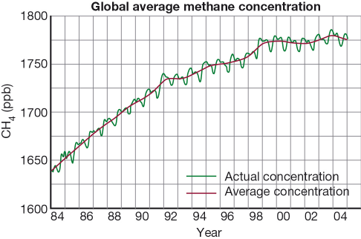  A The most rapid increase in methane levels in the atmosphere was from 1992 to 1998.  B Methane levels increased by 20% from 1984 to 2004.  C The concentration of methane in the atmosphere decreased from 1997 to 2004.  D There is an annual variation in methane concentration that follows a similar pattern each year. | D | 1
 | Calculate the percentage change in the concentration of gases in the atmosphere.  A carbon dioxide: 25 %; methane: 60%; nitrous oxide: 15%  B carbon dioxide: 34 %; methane: 152%; nitrous oxide: 18%  C carbon dioxide: 25 %; methane: 152%; nitrous oxide: 15%  D carbon dioxide: 34 %; methane: 60%; nitrous oxide: 18% | B | 1
  Gas concentration in the atmosphere (ppm)
  Year | 1750 | 2003
  Carbon dioxide | 280 | 376
  Methane | 0.71 | 1.79
  Nitrous oxide | 2.7 | 3.19
 | Using the information in the graph, calculate the average yearly increase in temperature from the year 1980 to 2007.  A 0.38°C  B 0.29°C  C 0.12°C  D 0.014°C | D | 1
 | 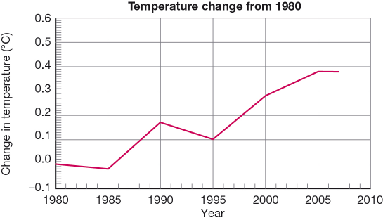  Using the graph in question 3, deduce the period when the temperature was increasing most rapidly.  A 1980 to 1985  B 1985 to 1990  C 1995 to 2000  D 2000 to 2005 | B | 1
 | 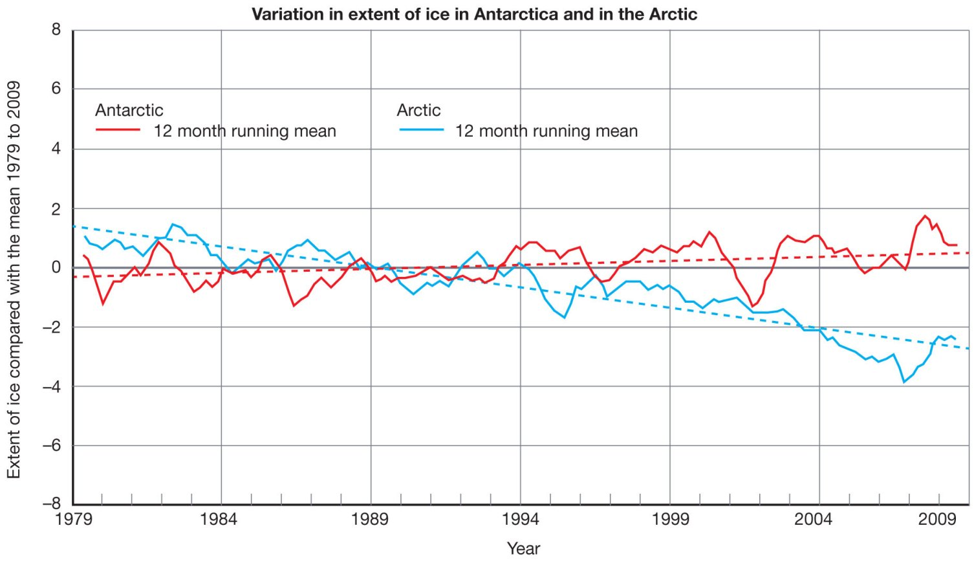  Only three of the statements below about changes in the ice at the poles can be supported by the data in the graph. Which statement CANNOT be supported?  A The area of ice in the Arctic has changed more in the time period shown than has the area of ice in Antarctica.  B Since 1989 there has been more ice in Antarctica than in the Arctic.  C The years 2000 to 2002 saw a sudden and rapid decrease in the area of ice in Antarctica.  D On average the area of ice in the Antarctic is increasing whereas the area of ice in the Arctic is decreasing. | B | 1
 | 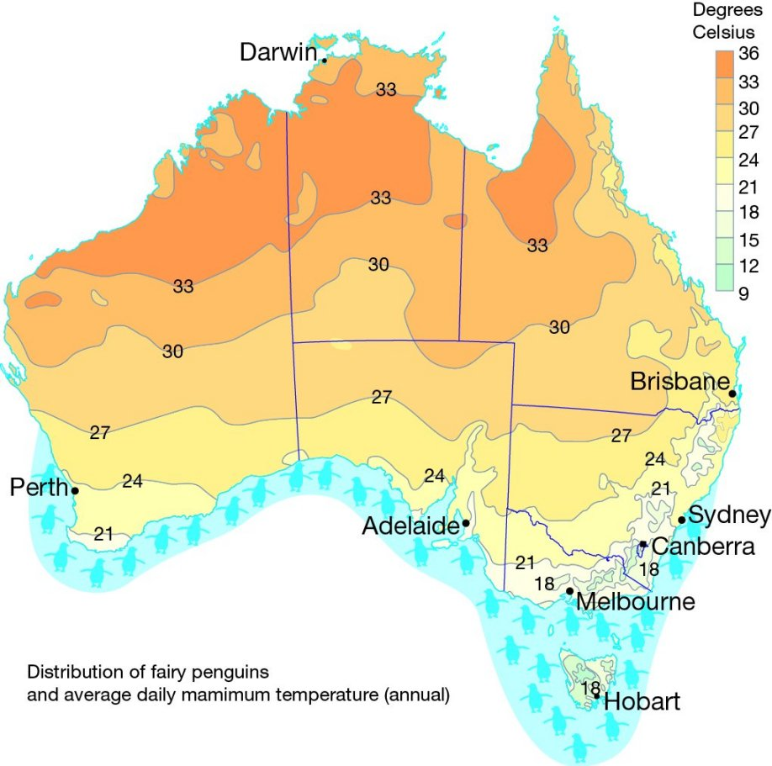  Study the map of distribution of the fairy penguin in Australia. Three of the statements below are supported by the information presented. Which statement CANNOT be supported?  A There is not an obvious relationship between temperature and the distribution of fairy penguins.  B Fairy penguins are limited to coastal areas where the average daily maximum temperature is below 27°C.  C Fairy penguins in Western Australia tolerate warmer temperatures than the penguins on the east coast.  D Fairy penguins will be able to tolerate temperatures below 18°C. | A | 1
 | 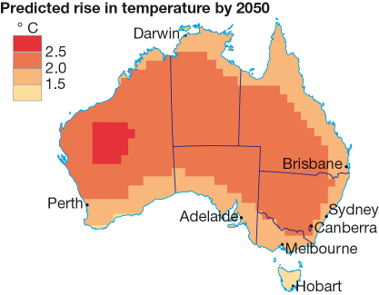  Using predictions based on continued high emissions of carbon, temperatures in Australia could increase up to 3°C by 2050. This information is shown in the figure above.  Using these predictions and the information about the current distribution of fairy penguins in question 6, what is LEAST likely to happen to fairy penguins in the future?  A The number of fairy penguins in Western Australia will be significantly reduced in number and restricted in distribution.  B In eastern Australia the northernmost populations of penguins will move further south.  C The populations of fairy penguins in Tasmania will increase in size as penguins move from the mainland.  D It is unlikely that there would be any populations of fairy penguins in South Australia. | D | 1
 | This diagram is of the carbon cycle in a natural ecosystem. Carbon continues to cycle in an urban area.  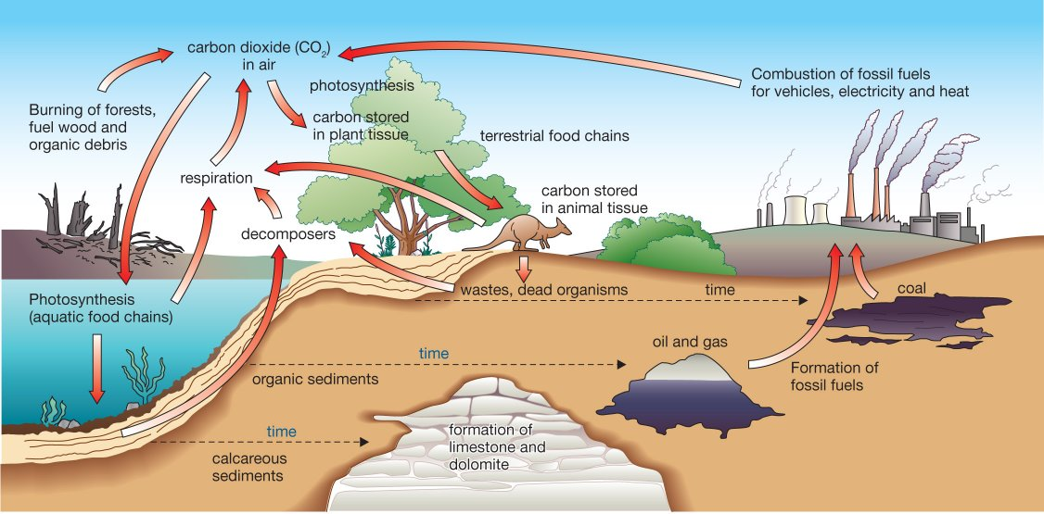  What is LEAST likely to be a difference in the urban carbon cycle?  A Less carbon would be taken out of the atmosphere by photosynthesis because there are fewer trees and other plants.  B Carbon would not be produced through decomposition because decomposition does not occur in cities.  C Carbon levels in the atmosphere would increase due to the number of petrol driven vehicles in the city.  D Carbon would be added to the cycle from outside the urban area in the form of food. | B | 1
 | 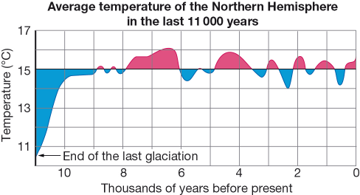  Use the graph above to identify the number of cycles of cooling and warming that have occurred in the last 11 000 years.  A 19  B 6  C 9  D 2 | C | 1
 | Using the graph in question 9, how many times in the last 11 000 years was the average temperature higher than it is at present?  A 9  B 6  C 3  D 2 | C | 1

This diagram relates to Section B question 2.

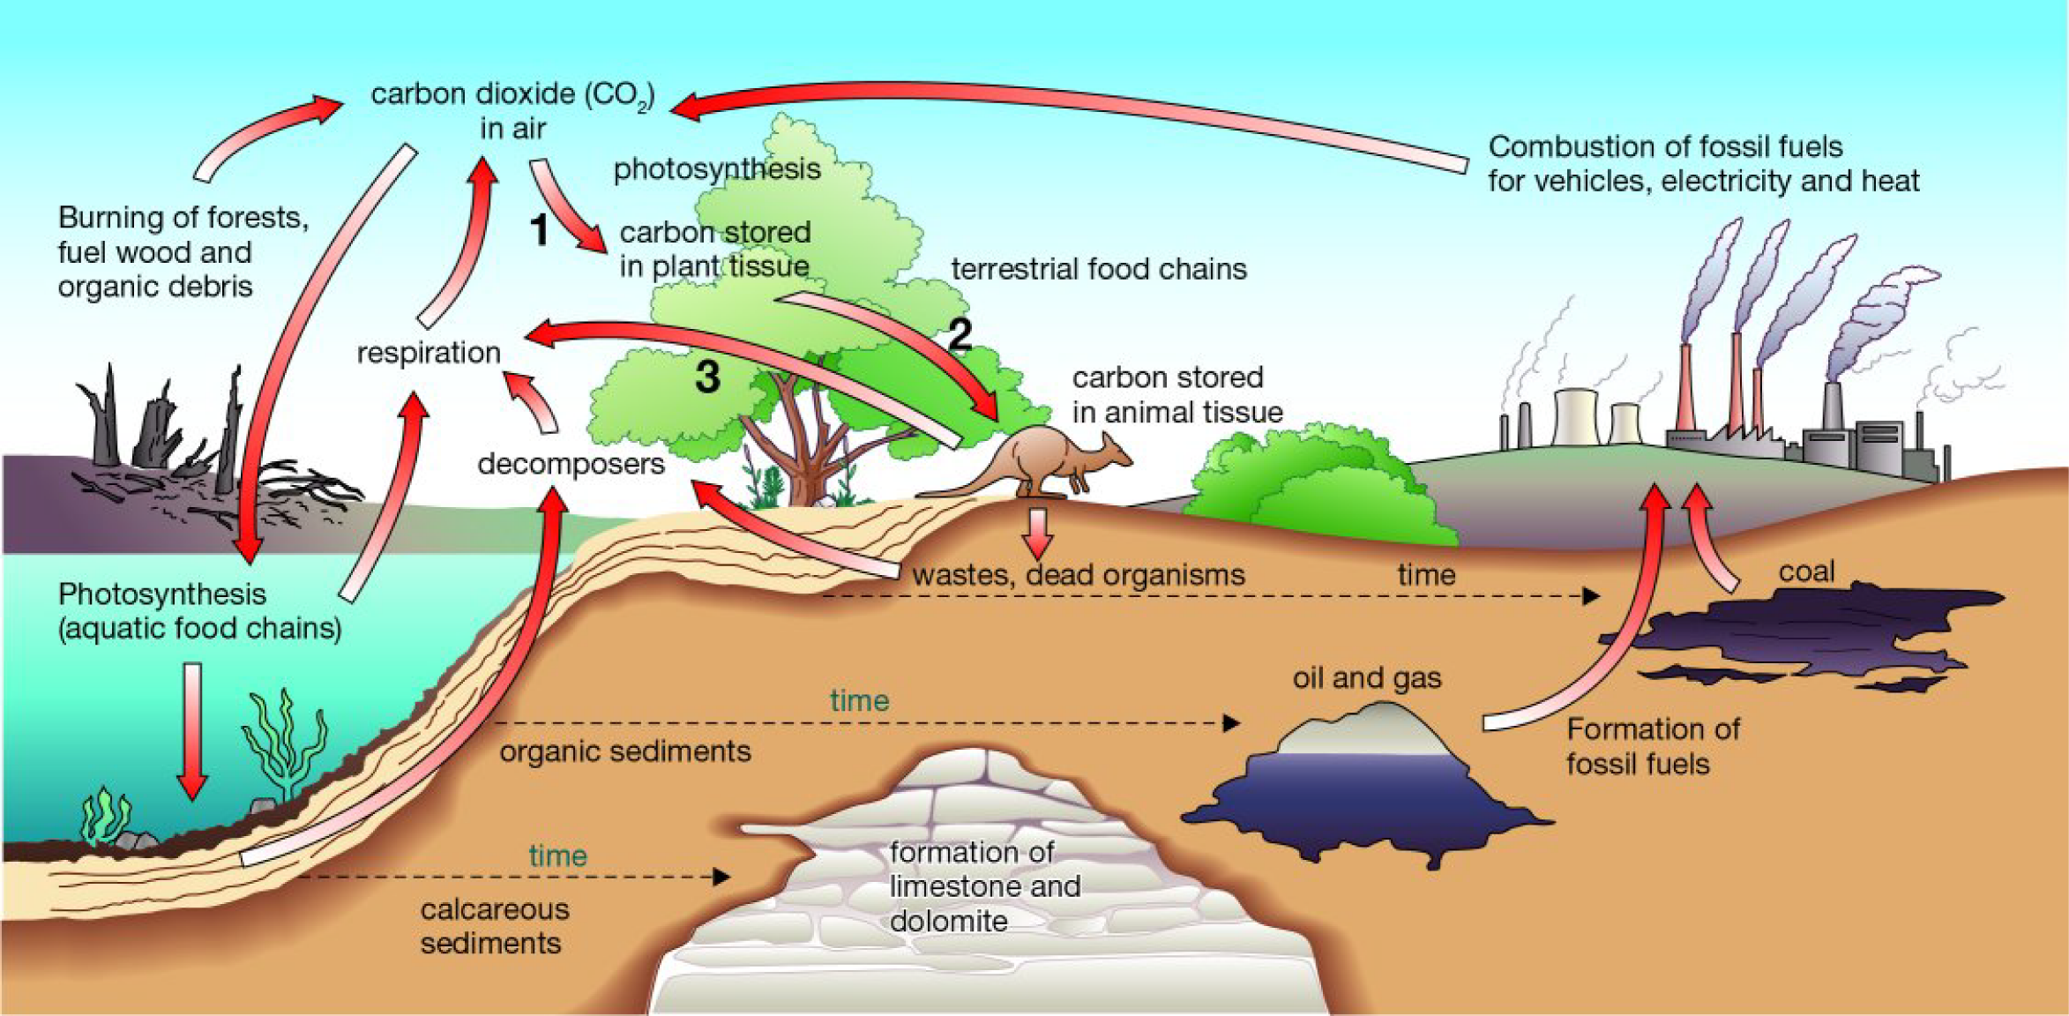

Figure 1
Part of the carbon cycle
This diagram relates to Section B question 4.

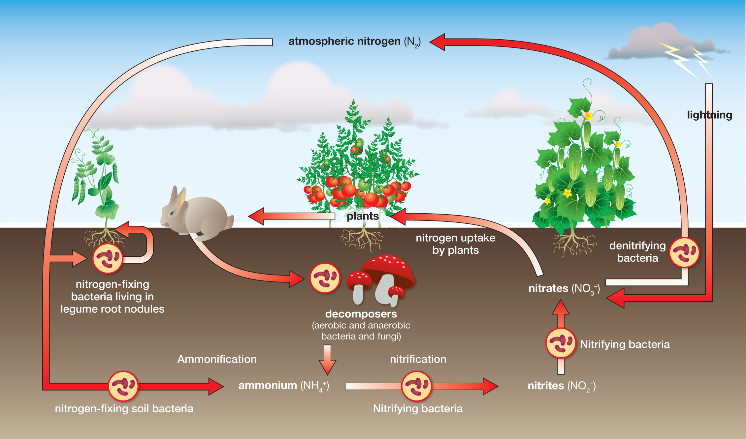

Figure 2
The nitrogen cycle

